**TRAGEDY OF FLIGHT- A COMPREHENSIVE CRASH ANALYSIS**

**1. Introduction:**

Airplane crash analysis is the process of investigating and analyzing the causes and contributing factors that lead to an aviation accident aim to identify the root causes of the crash, which could be human error, mechanical failure, environmental factors or a combination of these. The investigation process usually involves gathering evidence from various sources, such as eyewitness accounts, air traffic control data, cockpit voice recorders, flight data recorders and wreckage debris. The data is then analyzed to determine what happened, why it happened, and how it could have been prevented.

**Purpose:**

The purpose of airplane crash analysis is to improve aviation safety by identifying and mitigating risks and hazards that could lead to accidents. Findings from the analysis are used to develop and implement safety recommendations and regulations to prevent similar incidents from occurring in the future.

**2. Problem definition and design thinking:**

**EMPATHY MAP**

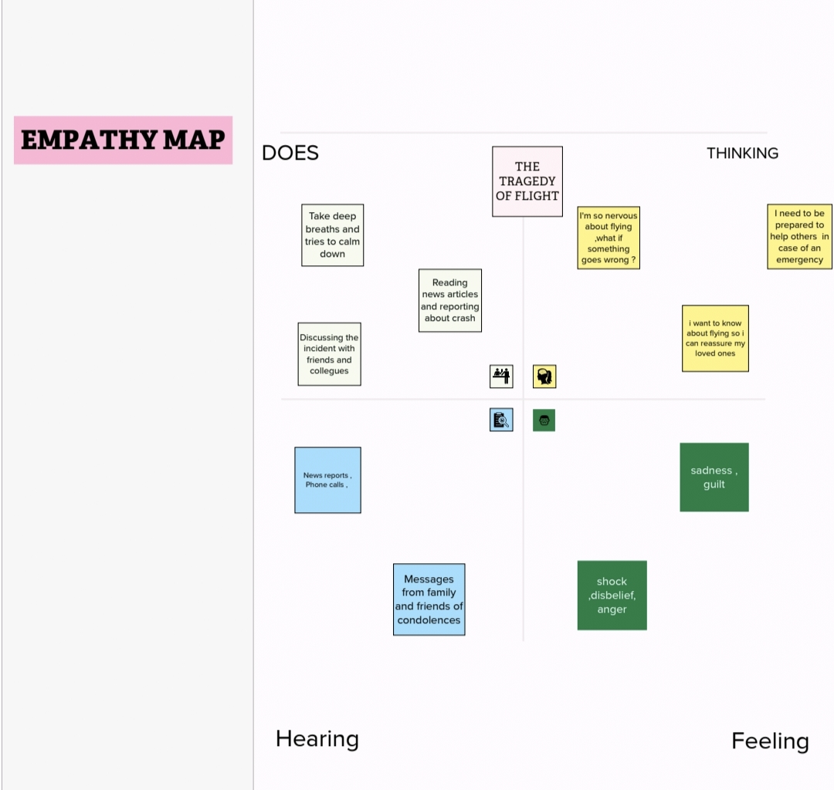

**IDEATION AND BRAINSTORMING**

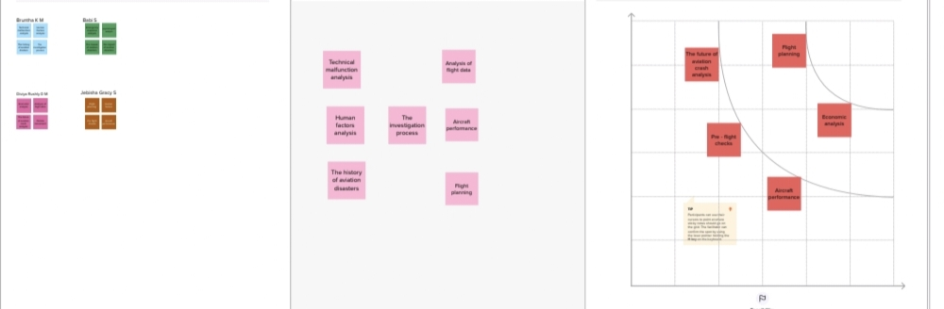

**3. Result:**

The data has been collected and visualized.

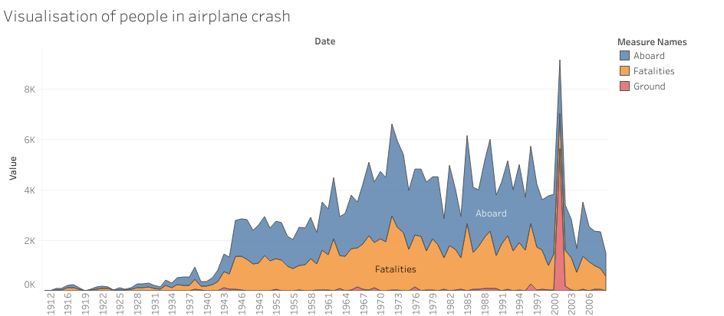

*In between the years 2000 and 2003 more number of people were aboard. There are more number of fatalities were shown in this graph. The ground level ratio is very less.*

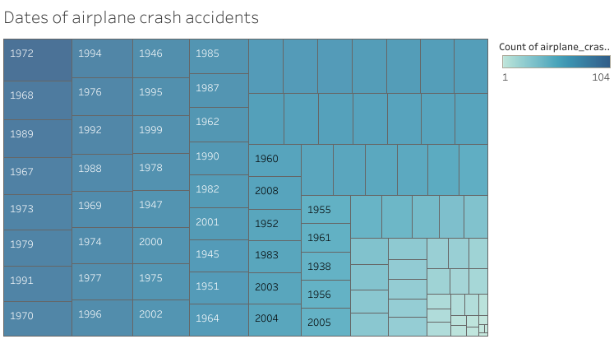

*This analysis shows the dates of aircrash accidents. According to this 1972 is the highest year of aircrash analysis.*

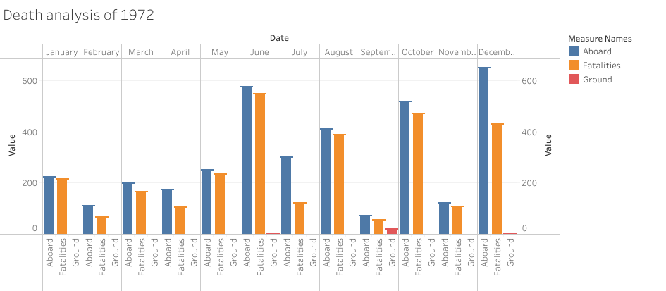

*In this analysis, the number of crashes in 1972 is shown.*

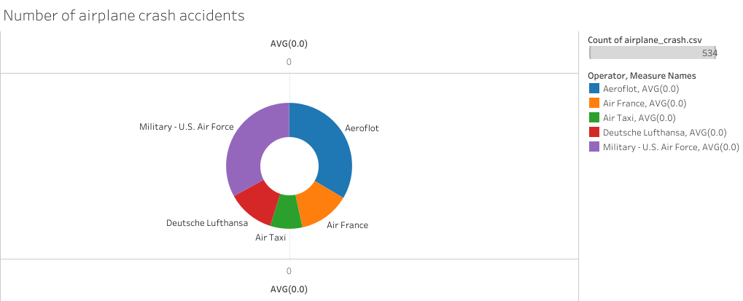

*This doughnut shaped analysis shows that the military US Airforce has done maximum count of airplane crash all over the world.*

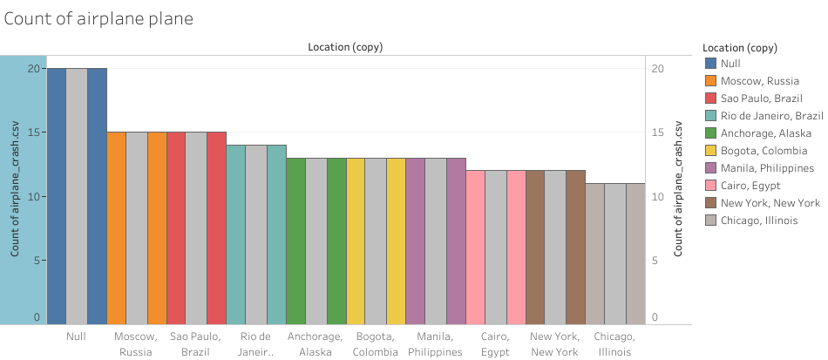

*Here the count of top ten crashes of airplane is shown.*

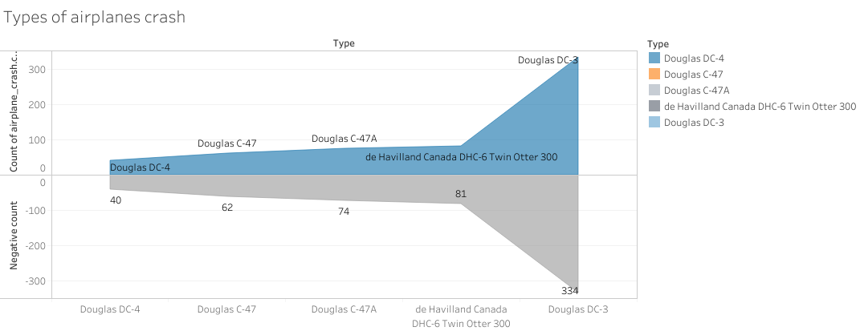

*This tunnel shaped analysis shows that the types of aircrashes in the history.*

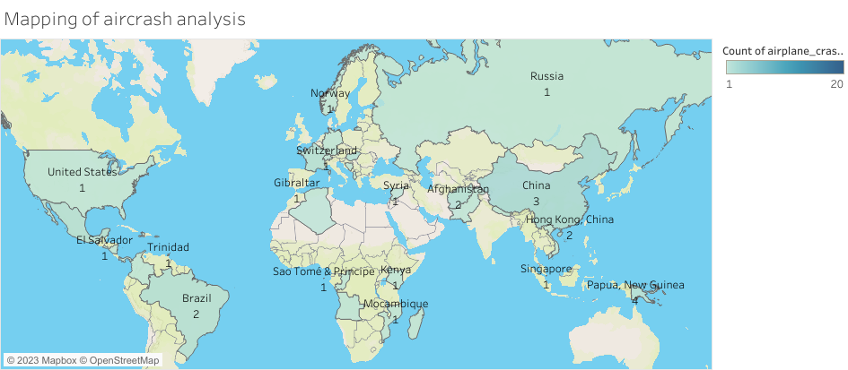

*The number of accidents in various regions in world is shown in this analysis.*

**4. Advantages:**

i) The primary advantage of airplane crash analysis is that it helps to identify the root causes of accidents and incidents, which allows for the implementation of safety measures to prevent similar accidents from happening in the future.

ii) The insights gained from airplane crash analysis can inform the design of new aircraft systems, and components, leading to improvements in safety and efficiency.

iii) The transparency and accountability demonstrated by the aviation industry in counting thorough accident investigations can help to increase public confidence in air travel.

**Disadvantages:**

i) Airplane crashes are tragic events that often result in the loss of life.

ii) Conducting a thorough crash investigation can be expensive.

iii) While crash investigations provide valuable data, they are rare events that provide limited information.

iv) Crash investigations are complex, and the findings can be difficult to interpret.

**5. Applications:**

One of the primary applications of airplane crash analysis is to improve aviation is to improve aviation safety by identifying the root causes of accidents and incidents and implementing measures to prevent them from happening again. Crash analysis can provide valuable information and expert testimony in litigation related to aviation accidents. It is also used by insurance companies to asses risk and determine premiums for aviation insurance policies.

**6. Future scope:**

AI can analyze large amount of data quickly and accurately, which could help investigators identify the root causes of accidents more efficiently. 3D printing could be used to create physical models of aircraft components and systems, which could help investigators better understand how they contributed to an accident. It will also help to stalk holders.

**7. Conclusion:**

This crash analysis helps to identify the root causes of accidents and incidents, which allows for implementation of safety measures to prevent similar accidents from happening in future. Furthermore, it can inform the development of training programs for pilots, air traffic controllers and maintenance personnel, which help to prevent similar accidents in the future.

**8. Appendix:**

In order to better understand the causes and consequences of airplane crashes, various organizations collect and analyze data on crashes around the world. This appendix provides an overview of the methods and data sources used in airplane crash analysis.

* **Data Sources:**

There are several sources of data on airplane crashes, including government agencies, airlines, and international organizations. The National Transportation Safety Board (NTSB) in the United States, the European Aviation Safety Agency (EASA) in Europe, and the International Civil Aviation Organization (ICAO) are among the most important organizations that collect data on airplane crashes.

* **Methodologies:**

Airplane crash analysis typically involves a combination of quantitative and qualitative methods. Quantitative methods involve statistical analysis of crash data, while qualitative methods involve the analysis of reports and other documents related to airplane crashes. Some of the key methodologies used in airplane crash analysis include:

* **Statistical Analysis:**

This involves analyzing data on airplane crashes to identify patterns and trends. Statistical analysis may involve the use of regression analysis, time series analysis, and other statistical techniques.

* **Root Cause Analysis:**

This involves analyzing the causes of airplane crashes to identify the underlying factors that contributed to the crash.

* **Human Factors Analysis:**

This involves analyzing the role of human factors in airplane crashes, such as pilot error, crew resource management, and communication breakdowns.

By analyzing airplane crashes, researchers can identify the causes of crashes and develop strategies to prevent future crashes from occurring. Ultimately, the goal of airplane crash analysis is to improve the safety and efficiency of air travel, and to ensure that air travel remains a safe and viable mode of transportation.